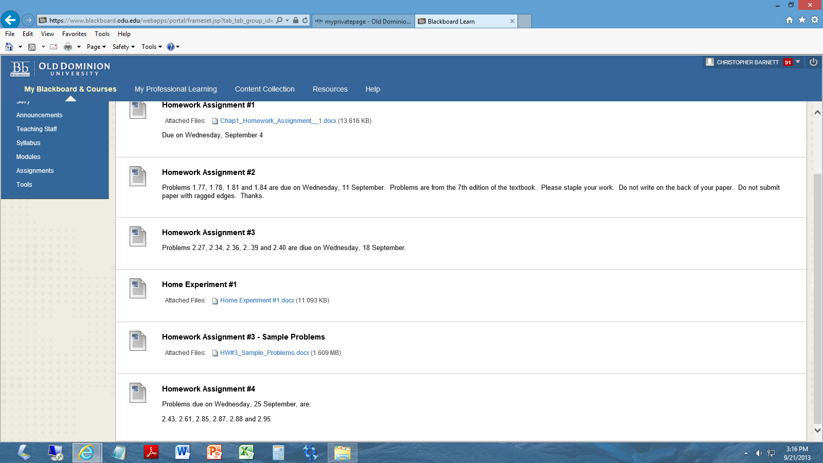

FBD for problem 2.87

FBD for problem 2.88

FBD for problem 2.95